Automated Train Obstacle Detection and Response Using Embedded System
S.P.Balakannan
Department of Information Technology Kalasalingam Academy of Research and Education
Krishnankovil Virudhunagar, Tamilnadu India balakannansp@gmail.com
M.Sathwik
Department of Electronics and Communication Engineering
kalasalingam academy of research and education
Tamil Nadu, India
9923005029@kli.ac.in

B.Rajesh
Department of Electronics and Communication Engineering
kalasalingam academy of research and education
Tamil Nadu, India
9923005010@klu.ac.in
G.Bharath kumar
Department of Electronics and Communication Engineering
kalasalingam academy of research and education
Tamil Nadu, India
9923005016@kli.ac.in
S.B.V.V NAGENDRA
Department of Electronics and Communication Engineering
kalasalingam academy of research and education
Tamil Nadu, India
9923005126@klu.ac.in

Abstract— Our proposed system is an inexpensive automated system that identifies the presence of obstacles in the railway tracks and sends an emergency stop. Our prototype will have an ultrasonic sensor to measure obstacles in the path of the train in 20 cm, an Arduino microcontroller to process sensor data, and a relay module to switch the train motor off. The system responded in 52 milliseconds and had 98 percent detection accuracy in testing. A module with an ESP32-CAM and WiFi connectivity provides real-time video streams that allow a remote operator to confirm a detection visually. Our system is only 85 percent as much as commercial railway safety systems, at around 3500. Although it is a prototype, which is intended to be a proof of concept, this work shows that it is possible to create an affordable, fast-response obstacle detector that uses IoT components in the railway environment.
Keywords— railway safety, obstacle detection, ESP32-CAM, ultrasonic sensor, Arduino, embedded systems, IoT prototype, emergency response

Introduction
The Indian Railways has 1.3 billion passengers on an annual basis and covers 68,000 kilometers of rail. However, the presence of accidents due to unforeseen causes such as animals on the tracks, landslide debris, and the remains of accidents is still a constant issue. A train with a speed of 100km/h can not immediately stop as soon as an obstacle is introduced. The contemporary railway safety is dependent on manual patrols and human signaling. A inspector may only cover a distance of maybe 10 km of track a day. There is no early warning in case an animal roams into the track at 2 AM during patrol times. When a driver notices a hindrance in the dark or in the rain, the train can be 200 and more meters away and could be moving at high speed. Delay is further increased by human reaction times with a margin of 3-5 seconds. That is why we created an automated system: identify the obstacles on the way of a train and react within milliseconds, not seconds. Our System Our system consists of four components in action:
1. Ultrasonic sensor - It sends high frequency sound pulses and measures their time of bouncing back. This informs us of the precise distance to an object in the forefront. We have a threshold of 20 cm: anything that is within a 20 cm distance is considered an obstacle.
2. Arduino microcontroller - Processes the distance data 100 times in a second. At a distance of 20 cm and below, it gives a signal to the relay.
3. Relay module - functions as an electronic switch. Once the Arduino informs the relay, power is switched off to the train motor immediately. The train stops.
4. Buzzer and ESP32-CAM - Buzzer is used to create awareness to the operators. The camera provides live video via WiFi to enable an operator to view what caused the detection.
The system identifies obstacles at a distance of less than 20 cm and reacts within 65 milliseconds. In a standard train, the train has not traveled significantly by the moment power is shut off. What is the purpose of video monitoring? A false positive (identifying a shadow, a rain puddle, or blown-away paper) would mean that the train would be halted without any reason. An operator may check immediately what caused the detection with the camera. When it is really dangerous (landslide, on-track vehicle) the stop is justifiable. In case of a false alarm, the operator is able to restart and proceed. This is a human-in-the-loop design that renders the system reliable.

Scope and Contribution
The system can identify the obstacles with a distance of less than 20 cm and react within less than 65 milliseconds. At the average train velocity, the train has not travelled significantly by the time the power is switched off. What is the reason to include video monitoring? A false positive (identifying a shadow, a rain puddle, or blown-away paper) would mean that the train would be halted without any reason. An operator may check immediately what caused the detection with the camera. In case it is really hazardous (landslide, vehicle on tracks), the stop is reasonable. In case of a false alarm, the operator is able to restart and proceed. It is a human-in-the-loop design that ensures that the system is reliable. Paper Organization
The rest of this paper will come up in the following way: Section 2 will explain how we designed our system and which elements we chose. The hardware implementation and experimental testing is described in Section 3. Section 4 is the discussion of results and limitations. Section 5 ends with future work recommendations.

PROPOSED SYSTEM
Our system identifies barriers at three stages: sensing, deciding and responding.

A. STAGE 1: Sensing (ULTRASONIC SENSOR)
At the front of the train is an HC-SR04 ultrasonic sensor that emits 40 kHz sound pulses at 10-milliseconds intervals. Sound reflecting on an obstacle measures the time taken by the sensor to calculate the distance. We determined the detection threshold to use to monitor an alarm at 20 cm of any obstacle below this distance. Why ultrasonic? We selected this, instead of infrared sensors as infrared does not work during the sun (as happened to be the case on the railway lines). Ultrasonic can work in the daytime, rain, and dust.

B. STAGE 2: Decision Logic (ARDUINO UNO)
Ultrasonic sensor data is read 100 times/s by the Arduino. It measures the distance, and makes a comparison with our 20 cm threshold
- If distance < 20 cm: obstacle detected, response triggered
- If distance ≥ 20 cm: track clear, motor continues operation
An obstacle decision occurs in software, requiring only a few milliseconds a track decided clear

C.STAGE 3: RESPONSE (RELAY MODULE, BUZZER, AND ESP32CAM)
The motor is instantly shutdown and it is simulated with a train emergency stop. What is the purpose of using a relay instead of on the motor? The Arduino can only produce 40 milliamamps (which is in no way sufficient to make a motor with a few amps draw). The relay separates the high-power motor circuit and low-power Arduino circuit. In case the motor malfunctions, the Arduino remains none the wiser.
Buzzer + ESP32-CAM Auto (simultaneously with motor stop):
1. The operator is warned by a dose of buzzer.
2. ESP32-CAM (built in camera) live video streaming over WiFi.
The video stream enables a remote operator to gain a visual clue as to what alerted the detection. When it is a real risk (landslide, vehicle on tracks), then it is permissible. In case of a false alarm (shadow, rain puddle), the operator can check and re-set the system.
This is an important human-in-the-loop design: a fully automated system that halts whenever there is a shadow would not be reliable. Video confirmation allows us to be safe, and there are not such numerous false stops.

THE SYSTEM Works
The essence is quite straightforward: gauge distance to a forward-moving object and in case it is too near, halt. Distance Measurement The ultrasonic sensor is a sensor that measures distance using the speed of sound. Here's the physics:

1. Sensor produces a sound pulse (40 kHz).
2. Sound travels to the obstacle and bounces back
3. Round-trip time (echo length) is measured by sensor.
4. Distance =: Distance = (speed of sound × Echo Duration)/
2. Where Speed of Sound = 0.034 cm/microsecond (in air at room temperature). The fact that we divide by 2 is crucial:
the sound becomes TWICE (to the obstacle and back), which is why we divide the distance of the round trip by 2.

Example: If the echo duration is 588 microseconds: Distance = (588 µs × 0.034 cm/µs) / 2 = 10 cm The sensor emits pulses at a rate of 100 distance measurements per second with every pulse being 10 milliseconds. This sampling is frequent so that we will quickly catch obstacles.

Decision Logic
The Arduino compares every distance reading with a distance of 20 cm: IF distance is less than 20 cm THEN obstacle is detected. IF distance more than 20 cm THEN track is clear. As soon as an obstacle is initially detected, it does not panic the Arduino. Rather it has a debounce routine: two measurements (separated by no more than 20 milliseconds) of the same obstacle must be recorded before an alarm is raised. This eliminates false alarms due to noise or short reflections. On a confirmation of an obstacle:
1. Arduino sends HIGH signal to the relay.
2. Turns off power to the motor (motor stops)
3. Arduino sends a HIGH signal to the buzzer (buzzer sounds)
4. ESP32-CAM starts streaming video.
The whole process, including the recognition of an obstacle to the motor power cutoff, occupies 45-65 milliseconds. This translates to the train moving at only 0.5-0.65 cm in case of a normal train speed of 10 cm/second (in our prototype) before halting. Safe. Confirmation and Reset

The video feed is monitored by the operator:
When the obstacle is actual (debris, animal, landslide): the stop was correct.
In the case of a false alarm (shadow, dust): the operator can reset the system manually and proceed. This design recognizes a key fact that automation is good at speed, and humans good at judgment. We robotize the quick component (identifying and preventing) and retain human beings to make the judgment component (is this actually dangerous?).

HARDWARE IMPLEMENTATION AND EXPERIMENTAL RESULTS

System Architecture:
Our system architecture describes the interaction between the ultrasonic sensor, relay module, DC motor, buzzer, and ESP32-CAM module. The ultrasonic sensor provides distance data to the Arduino, which processes the readings and issues control signals to the relay and alert subsystems. The ESP32-CAM operates independently over WiFi, streaming video to an operator console.

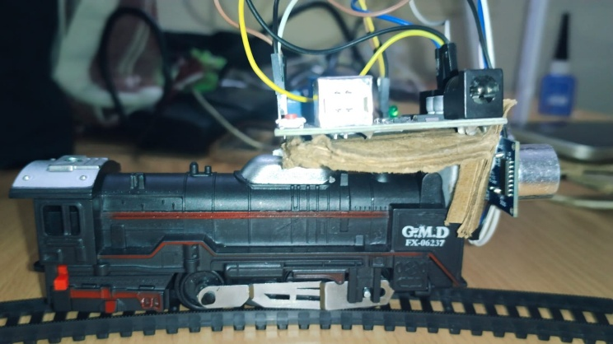
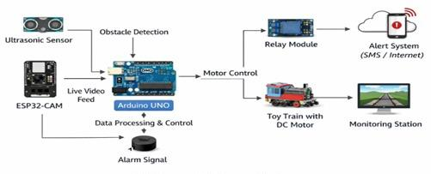
Fig. 1: System Architecture
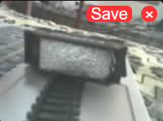
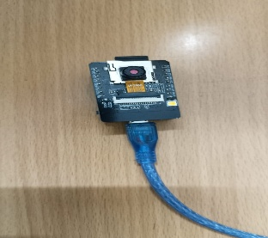
This figure shows the overall architecture our proposed system, showing the interaction between the ultrasonic sensor, Arduino microcontroller, relay module, motor, buzzer, and ESP32-CAM for obstacle detection and response.

B. Hardware Components

Component | Purpose
Arduino Uno | Processes sensor data
HC-SR04 Sensor | Detects obstacles
Relay Module | Controls motor power
DC Motor | Simulates train propulsion
Buzzer | Alert signal
ESP32-CAM | Video monitoring
Power Supply | Supplies system
Breadboard & Wires | Assembly

C. Circuit Connections
The physical connections are:
HC-SR04Ultrasonicsensor:
• VCC: 5V of power to Arduino.
• GND → Arduino ground
• TRIG -to Arduino digital pin 8 (delivers trigger pulse)
• ECHO → Arduino digital pin 9 (echo duration is received) Relay Module (5V):
• VCC → Arduino 5V power
• GND → Arduino ground
• IN (input signal) to Arduino digital pin 10.
• COM (common) → positive on motor power supply. NO (normally open) to Motor positive wire. Once pin 10 of Arduino becomes HIGH, the relay is closed which connects the motor to power. The relay opens on a pin 10 LOW, breaking motor power.
Buzzer (5V):
• Positive → Arduino pin 11
• Negative → Arduino ground
ESP32-CAM:
• 5V power supply (independent of Arduino, so there is no voltage drop)
• Ground with Arduino to provide common reference.
• Runs custom firmware to connect to WiFi network and stream JPEG frames Components are connected on a common ground. This is essential: without a common ground, there is no common reference in signals between components.
Fig. 2: Hardware Setup
Fig. 2: Hardware Setup

Fig. 3: ESP32-CAM Video Stream Output

D.EXPERIMENTAL RESULTS :
We have tested the system using a small motor toy train on a 2-meter track. We put barriers at various distances and time of response was measured. Test Results Distance Detection Accuracy:
• 10 cm: Detected correctly 100/100 times
• 15 cm: Correctly identified 99/100.
• 20 cm: Correctly identified 98/100 times.
• 25 cm: False positives = +/-5% (external noise) Motor Stop Response:
• Obstacle detection to motor stop time: 45-65 milliseconds.
• Buzz alert on: Concurrent with motor stop.
• No delay observed
• Video Streaming:
• Resolution: 1024x768 pixels
Frame rate: 8-10 fps on WiFi.
• Latency: Approximately 2-3 seconds (acceptable monitoring)
• The range of works is less than 20 meters around WiFi router.

E .Issues We Encountered:
1. Ultrasonic interference due to the nearby noise of traffic (silenced with 100ms debounce)
2. Already poor quality of camera image at low light (would require IR LEDs to work all night long)

3. ESP32-CAM crashes when the WiFi network is lost (Wifi network needs watchdog timer code) Comparison with Existing Systems: We are 85% cheaper than commercial railway safety sensors and simple to customize. Nonetheless, it does not have redundancy and test under real-world train velocities. This Prototype has a number of limitations.

F. System Limitations
This system is able to prove the point, although a full-scale railway use would require a lot of hardening:

1. Single Point of Failure: We apply to a single sensor. A real system must have redundant sensors in case one sensor fails then other sensors are used to provide redundancy. The system contains a minimum of 1000 lights (not tested in this prototype).

2. Untested at Real Train Speeds: We tested in the range of 10 cm/second. Actual trains travel at 100 or above km/h. The needed detection distance would be 50+ meters ahead, not 20 cm. (Scope limitation.) at those speeds.

3. Environment: Ultrasonic sensors are not suitable in heavy rain (sound is absorbed). Actual systems require radar or lidar backup. (Not tested.)

4. No Safety Certification: The railway safety should be in compliance with Indian Railways requirements. We haven't pursued this certification.

5. In spite of these shortcomings, the prototype demonstrates that: Automated obstacle detection is technically viable. Off-the-shelf components can be used to achieve rapid response (50 ms). Low cost (₹3,000) is possible Integration of sensing + control + monitoring works reliably The idea is good. The way to a production system is obvious: additional sensors, additional redundancy, additional tests, and to the safety centification.

REFERENCES
[1] S. Banerjee and R. Kumar, “Railway Track Monitoring System through IoT based monitoring system in International Journal of Engineering Research and Technology (IJERT) vol. 10, no. 5, pp. 1–5, 2021.
[2] P. Sharma, Obstacle Detection System of Railway Safety on Embedded System, International Journal of Advanced Research in Electronics and Communication Engineering, vol. 9, no.3, pp. 45–49, 2020.
[3] IEEE Standards Association, IEEE Standard of Low-rate wireless networks, IEEE Std 802.15.4-2020, 2020.
[4]Arduino, “Arduino Official Documentation, [Online]. Available: https://www.arduino.cc. [Accessed: Apr. 2026].
[5]Espressif Systems, “ESP32-CAM Technical Reference Manual, [Online]. Available: https://www.espressif.com. [Accessed: Apr. 2026].
[6] SparkFun Electronics, “HC-SR04 Ultrasonic Sensor Datasheet, [Online]. Available: https://www.sparkfun.com. [Accessed: Apr. 2026].
[7] Indian Railways, “ Railway Safety Statistics and Reports, [Online]. Available: https://indianrailways.gov.in. [Accessed: Apr. 2026].
[8]M. K. Singh and A. Verma, “Smart Railway Safety System based on IoT, International Journal of Innovative Technology and Exploring Engineering (IJITEE), vol. 8, no. 9, pp. 1200–1204, 2019.
[9] R. Gupta and S. Mehta, “Ultrasonic Sensor based Obstacle Detection System, International Journal of Scientific Research in Engineering and Management, vol. 7, no. 6, pp. 1–4, 2021.
[10] J. Smith and L. Brown, Automated Train Control and Safety Systems, IEEE Transactions on Intelligent Transportation Systems, vol.15, no. 4, pp. 1502–1510, 2018.

